Case Study – “Mask detection with machine control” for Enzymatic Powder Environment.
Objective – Our client, which manufactures detergent powder, wanted to implement a mask detection system to monitor whether the operators are wearing masks. The enzymatic detergent powder if inhaled above a certain quantity can be harmful to one’s health. It is mandatory for all operators as well as other personnel to wear masks while they are on the shop floor, but sometimes this practice is not followed.
Compliance – Health safety as per internal EHS guidelines to prevent inhalation of enzymatic powder.
Solution –
- Multiple cameras per machine to detect operator from all angles.
- High performance AI PC at every machine for computer vision processing
- In the vision software, 3 zones (red, orange, and yellow) were created depending on the risk associated. The operator is exposed most to the enzymatic powder in the red zone, and least exposed in the yellow zone. If a violation occurs when the operator is in the red zone, the machine is stopped immediately.

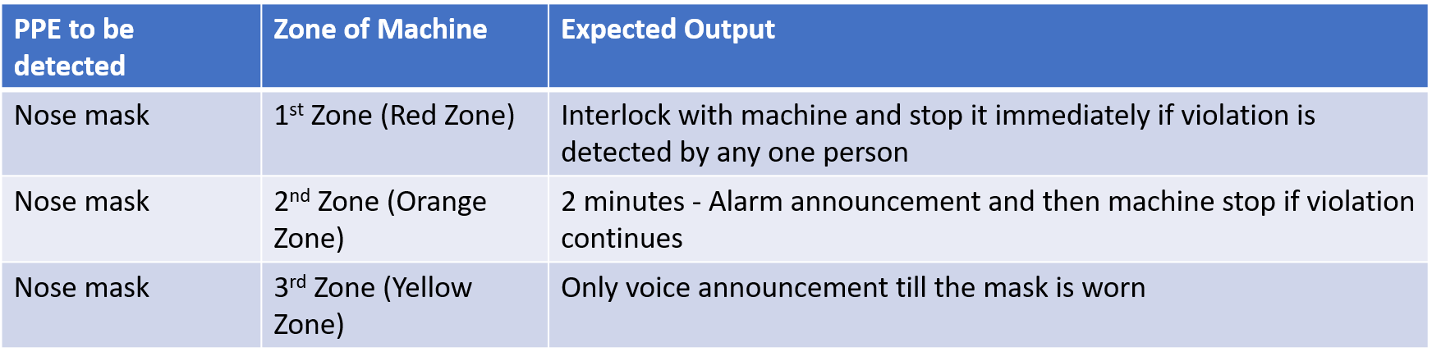

- Server station, live camera feed, and analytics dashboards to monitor violations per shift/machines/zones
- The analytics dashboard shows the following data –
  - Total violations per day
  - Machine-wise violations with top offending machines
  - Zone-wise violations
  - Snapshot of operators causing the violations
  - Daily trend analysis
- Integration of machine vision system with existing PLC for voice alarm and machine stoppage

Solution Architecture –

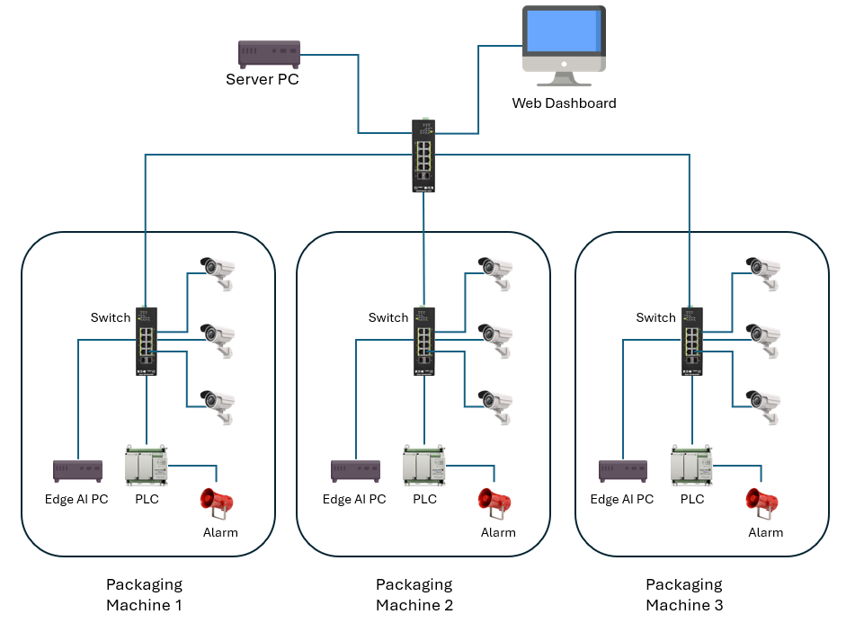
Solution Architecture

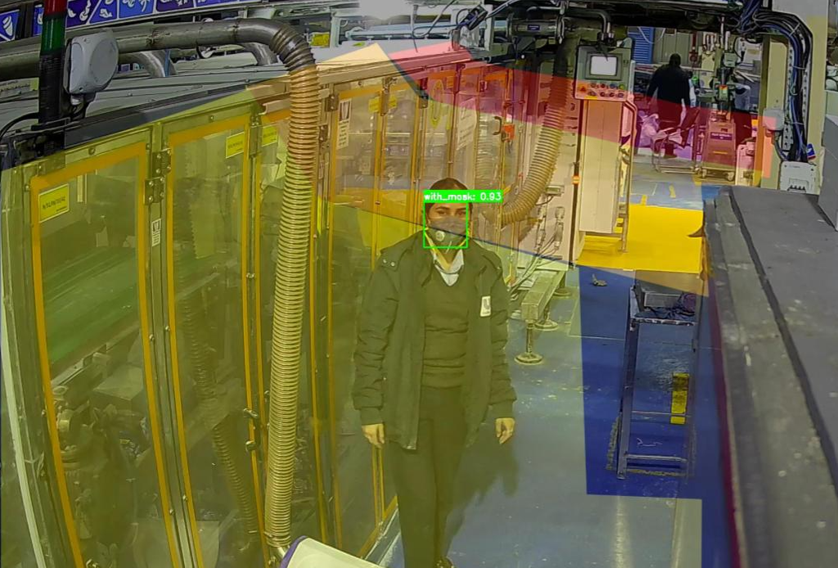
Creation of different zones based on the risk of inhaling enzymatic powder
Analytics Dashboard

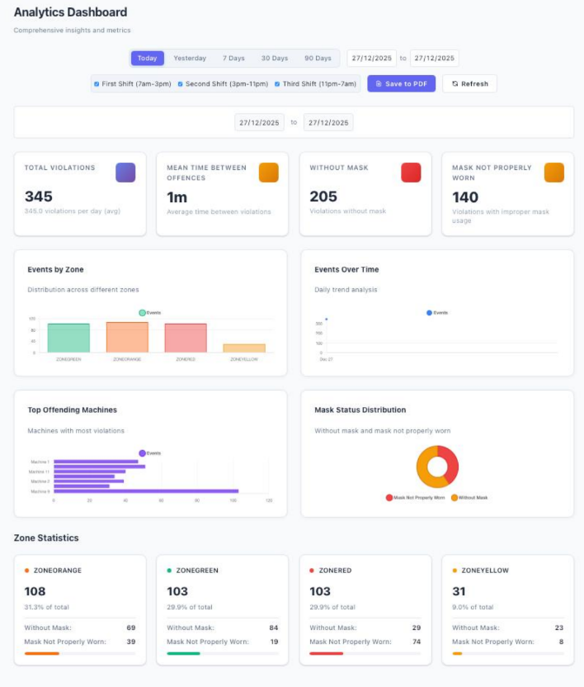

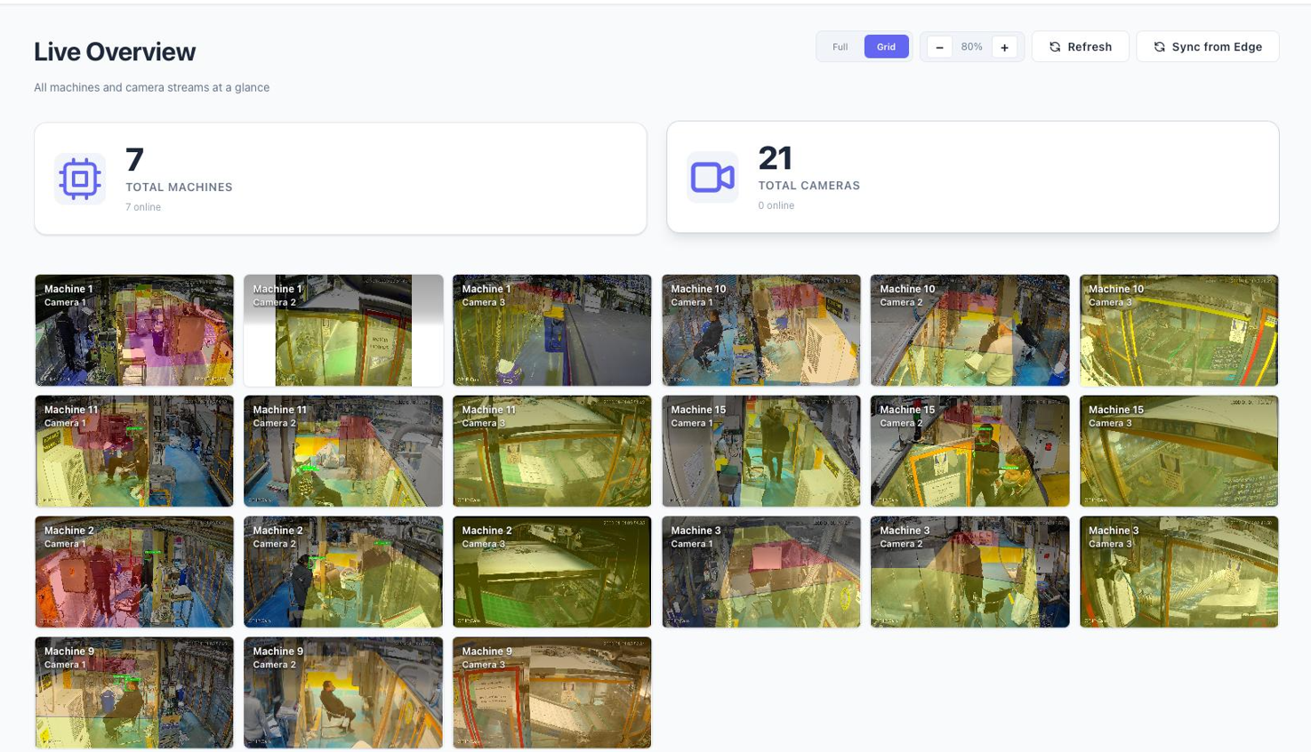
Real-time streams of all cameras

Benefit –
- 98% accuracy- Reliable detection of mask.
- Health Protection- Prevents inhalation of hazardous powder dust.
- Real-Time Alerts – Immediate action on non-compliance.
- Analytical Dashboard – Enables EHS teams to:
Track compliance trends.
Fix accountability.
Implement corrective measures and evolve policies.

